|  |  |  |  |
| --- | --- | --- | --- |
| **Laboratory:** | **Document Type:** | **Original Date Adopted:** | **Previous Document:** |
| Lab Admin | Procedure | July 20, 2019 | ADMIN-148 Revision 2 |

|  |  |  |
| --- | --- | --- |
| **Document Author:** | **Document Owner:** | **Acknowledgement / Required Copy Holders*:** |
| Megan Board  Sandra VanVranken | Sandra VanVranken | All laboratory testing personnel, and others deemed applicable staff members and faculty. |

|  |
| --- |
| **Approval*:** |
| Laboratory Administrative Division Director  *CLIA / CAP Laboratory Medical Directors*  OSUWMC/The James Clinical Laboratories Medical Director, East Hospital Laboratory Medical Director, Morehouse Laboratory Medical Director, Spielman Laboratory Medical Director, Outpatient Care East Laboratory Medical Director, Outpatient Care Lewis Center Laboratory Medical Director, Outpatient Care Gahanna Laboratory Medical Director, Outpatient Care New Albany Laboratory Medical Director, James Molecular Laboratory Medical Director, Ackerman Laboratory Medical Director  *CLIA Laboratory Director*  Outpatient Care Labs - UA and Hilliard  Histology LLC Laboratory Medical Directors at Doan, East, Morehouse, Chambers Road and Department of Pathology |

|  |
| --- |
| **\*Approval and Acknowledgements\*** |
| Refer to QPulse system and Document Details report for laboratory directors(s)’ electronic signature approval, employee acknowledgment and effective date. |

1. **POLICY** 
   1. General instructions for laboratory personnel during a scheduled or unscheduled LIS downtime.
2. **PURPOSE OF DOCUMENT**
   1. To ensure reporting of patient results occurs in a prompt and efficient manner during partial or complete IHIS downtime until recovery of the system.
3. **SCOPE OF DOCUMENT**
   1. This document applies to all personnel in any Clinical, Pathology, or URL Laboratories throughout the Ohio State University Wexner Medical Center, as well as direct support services to the laboratories (i.e. IT, Pathology Support Services, etc.).
4. **RESPONSIBILITY** 
   1. The Medical Directors of the Laboratories are responsible for establishing the Downtime Procedure.
   2. Laboratory Compliance is responsible for maintaining the document and ensuring biennial review.
5. **Definitions**
   1. Unscheduled Outage: Any unplanned interruption to the availability of a major hospital system that supports critical patient care functions.
   2. Scheduled Outage: Planned/maintenance outage that typically occurs the second Sunday of the month from 1:30AM-3:30AM.
   3. GroupMe: Application used to notify key individuals of the status of a scheduled or unscheduled IHIS or ancillary clinical system outage.
6. **PROCESS – Scheduled Downtime**
   1. Prepare all testing areas for downtime by setting analyzers to print all results (see area specific procedure).
   2. Locate downtime box or binder with downtime labels and extra Downtime Requisitions.
      1. Requisitions can be purchased through Workday with OSU item #10129240 (Lab Downtime Form) for a pack of 100 forms by the patient care unit/department. Inpatient processing areas, ambulatory phlebotomy sites, and Laboratory Compliance keep a limited number of forms in case of emergency.
   3. **IHIS Downtime (Shadow):** If only live (production) IHIS is down, the Downtime (shadow) version of IHIS may be available. This is read only but allows searching and reviewing patient information similar to the live environment.
      1. IHIS Downtime can be accessed by clicking the Start Menu > All Programs > IHIS Downtime (folder) > IHIS Downtime.



* + 1. Log in with your IHIS user name and password.
    2. Alternatively, from the OneSource home page, click **View More**.



* + 1. Scroll down to Citrix and click the web address link.



* + 1. Log in to Citrix with your IHIS username and password.
    2. Click the IHIS Downtime folder.



* + 1. Click the IHIS Downtime icon.



* + 1. Log in with your IHIS username and password.
  1. **Downtime Report:** Print downtime report(s) by laboratory area ([see Accessing IHIS Downtime Tip Sheet](https://onesource.osumc.edu/departments/IHIS/Tip%20Sheets/Accessing%20IHIS/Accessing%20IHIS%20During%20a%20Downtime.pdf)).
  2. **BCA Computers:** The Business Continuity Access (BCA) computer is designated by a red keyboard.
     1. Depending on your location, the BCA Printing icon may be located on the desktop, the Start Menu or may appear as an icon along the bottom left of your screen.

  

* + 1. Click the icon to open BCA.
    2. Enter your IHIS username and password.



* + 1. If you are using a shared BCA PC (generally ambulatory areas), select the appropriate department(s) on the left side of the screen.



* + 1. You may also select a specific report type from the bottom, left side of the screen as needed.
    2. The available reports appear in the center of the screen. Reports are titled “Lab BCA (Department) Outstanding List.” If you do not see your department’s report listed, use the left side of the screen to filter and locate your laboratory’s information (seen in the image for section 6.1.4.d above).

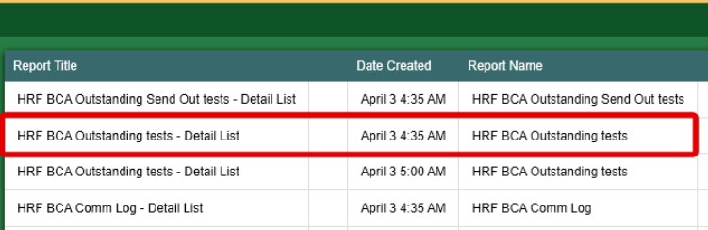

* + - 1. Select the report(s) you want to print. (Hint: Hold the shift key to select multiple documents.)
      2. Alternatively, click the Select All button along the bottom of the screen.



* + - 1. Click Print.
      2. If prompted, select the correct printer.



* + - 1. Click Print.
      2. Log out when finished.

1. **PROCESS - Unscheduled downtime:**
   1. General Concepts
      1. Contact the Help Desk at 614-293-HELP (4357).
      2. Prepare all testing areas for downtime by setting analyzers to print all results (see area specific procedure).
      3. Print downtime report(s) by laboratory area (see 6.1.4).
      4. Timeline and actions to take (designate an employee as the communication liaison):
         1. At 30 minutes, call all stat results, fax and/or tube if necessary. Begin processing routine samples.
         2. At 45 minutes, notify the laboratory manager, administrative director, and division(s) directors.
   2. **Middleware (interface) downtime:**
      1. Contact the Help Desk at 614-293-HELP (4357).
      2. Prepare all testing areas for downtime by setting analyzers to print all results (see area specific procedure).
      3. Timeline and actions to take (designate an employee as the communication liaison):
         1. At 30 minutes, begin manually entering results into IHIS, as applicable. Refer to individual laboratory downtime policy. Begin processing routine samples.
         2. At 45 minutes, notify the laboratory manager, administrative director, and division(s) directors.
      4. Specimens can still be received in IHIS but analyzers will not recognize barcode information. All orders require manually programming on the analyzer using the master patient index (MPI). The MPI is a unique barcode number. Program the analyzer using two patient identifiers (patient legal name and MRN), the MPI, and each test requested.
   3. **Types of specimens received during a downtime:**
      1. All orders require manually programming on the analyzer using the MPI. Program the analyzer using two patient identifiers (patient legal name and MRN), the MPI, and each test requested.
      2. Specimen has an IHIS order and has been collected and received.
         1. Will have an uptime barcoded label. This will need to be manually programmed on the analyzer, or middleware using the uptime MPI. Results will be held until the downtime is over. Results will not be electronically transmitted until the downtime is over.
      3. Specimen has an IHIS order and is collected only (not received).
         1. Will have an uptime barcoded label. This will still need to be manually programmed on the analyzer using the uptime MPI. Results will be held until the downtime is over. Results will not be electronically transmitted until the downtime is over.
      4. Specimen has an IHIS order only (neither collected nor received).
         1. Requires a manual/downtime requisition and a downtime barcode label. Program the analyzer using the downtime MPI. Results will be held until the downtime is over. Results will not be electronically transmitted until the downtime is over.
      5. Specimen does not have an IHIS order.
         1. Requires a manual/downtime requisition and a downtime barcode label. Program the analyzer using the downtime MPI. Results will be held until the downtime is over. Results will not be electronically transmitted until the downtime is over.
   4. **Processing Areas:** 
      1. When IHIS is down, orders already placed will be on the downtime report available via the BCA computer. Orders placed prior to the downtime will have an uptime barcode label. Orders placed at the start of the downtime and after will be sent to the laboratory with a manual/downtime requisition (found in the patient care unit/department’s downtime box) and chart/bedside labels on the tubes.
         1. Information required for a downtime/manual requisition:

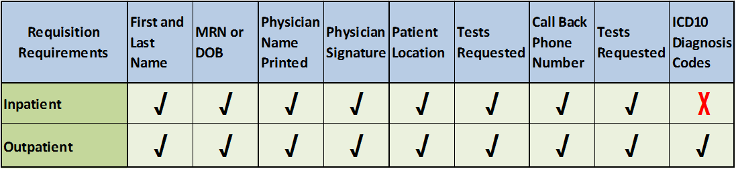

* + 1. **Printing Labels:** Each laboratory is responsible for preprinting and maintaining downtime labels. 299 labels can be printed at a time. Continue to follow the below instructions until the amount necessary for your area is achieved. These are to be printed every calendar year and should be checked periodically for deterioration/loss of adhesive ability.
       1. To print labels:
       2. Select Lab Tools and then Downtime Specimen Creation.

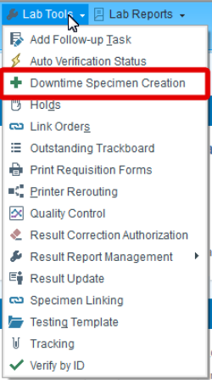

* + - 1. The Laboratory field will automatically populate.
      2. Enter Number of Specimens to print (maximum of 299).
      3. NOTE: Prior to printing large quantities of downtime labels, print one test label to ensure formatting and alignment is satisfactory.
      4. Enter “1” in the Labels per Specimen field, unless specified by the downtime procedure specific your lab.

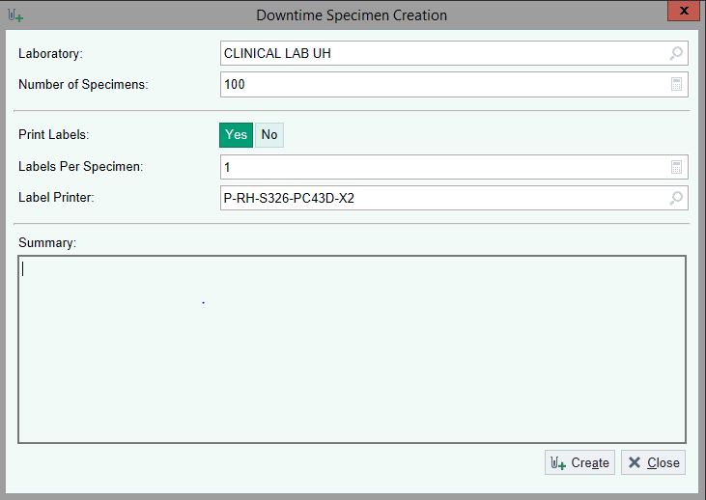

* + - 1. Select your department’s printer.
      2. Select Create.
      3. Repeat until the desired number of labels are printed.
      4. Labels are kept in a box labeled “DOWNTIME LABELS”. Left side of the barcode will go on the downtime requisition, and the right side of the barcode will go on the specimen. 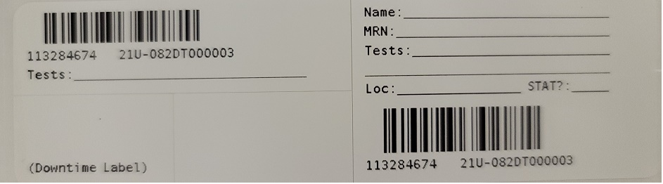
    1. **Process for Extended Downtime:** When IHIS is down, begin by writing downtime labels for all STAT tests. If there is an **EXTENDED** downtime (greater than 30 minutes) use this procedure for applicable tests. Always process stat specimens first.
       1. Spin all specimens, and process at least the samples needing to be completed within 8 hours.
       2. On the specimen barcode label (right side of the label) write: patient legal name, MRN, Test(s) ordered, Nursing Unit or Location and phone number if provided. (If tests are to be run STAT, STAT needs to be noted on the label).
       3. Put the specimen barcode label on the tube (right side of the label).
       4. Centrifuge all tubes that need to be spun.
       5. Repeat the process for each tube type on a single requisition.
       6. Deliver all tubes to appropriate testing areas.
    2. Place the left side of barcode label corresponding to a particular tube type on the requisition.
       1. Write the tests associated with the barcode and tube type on this label.
       2. Repeat this process for each tube type on a single requisition.
    3. **Requisition:**
       1. Keep the original requisition in the processing area to be used for entering the tests into the computer when downtime is over.
       2. Make a copy of all requisitions with the downtime barcode labels and associated tests indicated on each label. These copies will be used to link results when the downtime is over.
    4. **Results:** Results for extended down time periods:
       1. Hard copy results will be kept in a designated place. Use either your laboratory’s specific form or instrument printouts. Either form must have the appropriate patient and required regulatory information. Ensure reference ranges are current if they are provided on the patient result report. Original copies of results will be kept in the laboratory. A copy of the original results will be sent if they are delivered via tube system or dumbwaiter instead of fax.
       2. Please refer to laboratory specific procedures for the use of the 5 OSUWMC System Core Laboratories downtime results forms, Admin-151 OSUWMC CP Downtime Result Forms.
       3. All STAT results will be called in real time. Results can be faxed/tubed to floor/doctor only if necessary.

1. **PROCESS – Downtime Recovery** 
   1. **Processing personnel:**
      1. Specimen has an IHIS order and has been collected and received.
         1. Does not need further processing.
      2. Specimen has an IHIS order and is collected only (not received).
         1. Receive the specimen(s) as a normal uptime sample. Refer to Admin-147 Beaker Activities Overview (Receiving Activities section).
      3. Specimen has an IHIS order only (neither collected nor received).
         1. Receive the specimen(s) using Order Entry (inpatient) or Order Inquiry (outpatient). Refer to Admin-147 Beaker Activities Overview and the Placing Order in the Lab Tip Sheet.
      4. Specimen does not have an IHIS order.
         1. Order, collect, and receive downtime test requests via Patient Station activity. Refer to Admin-147 Beaker Activities Overview and the Placing Orders in the Lab Tip Sheet.
      5. Provide the testing personnel with the completed requisition.
   2. **Testing personnel:**
      1. Link the patient results ensuring the uptime barcode container type and test orders match the downtime barcode container type and test orders placed on the requisition.
      2. Select Lab Tools and then Specimen Linking. Lab Tools can be found on the My Epic Menu and Toolbar, or under the Epic Menu button then scroll down to Lab Tools.

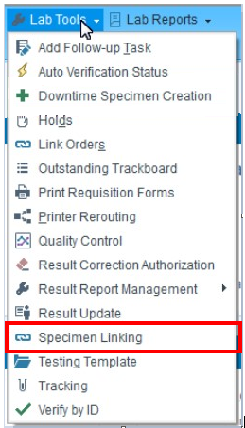

* + 1. Specimen Linking can also be found my using the Search feature, and typing in linking or specimen linking and then selecting Specimen Linking.

* + 1. The left pane will list all pending samples that were tested on the analyzer with a downtime label. The right pane is used to view the uptime barcode information.
       1. NOTE: If the Specimen Linking worklist is extensive, a specific downtime MPI can be quickly located on the list by highlighting any specimen, clicking Ctrl+F, scanning or entering the downtime MPI, then clicking [Next].
    2. If possible scan the downtime MPI for faster, more accurate locating.

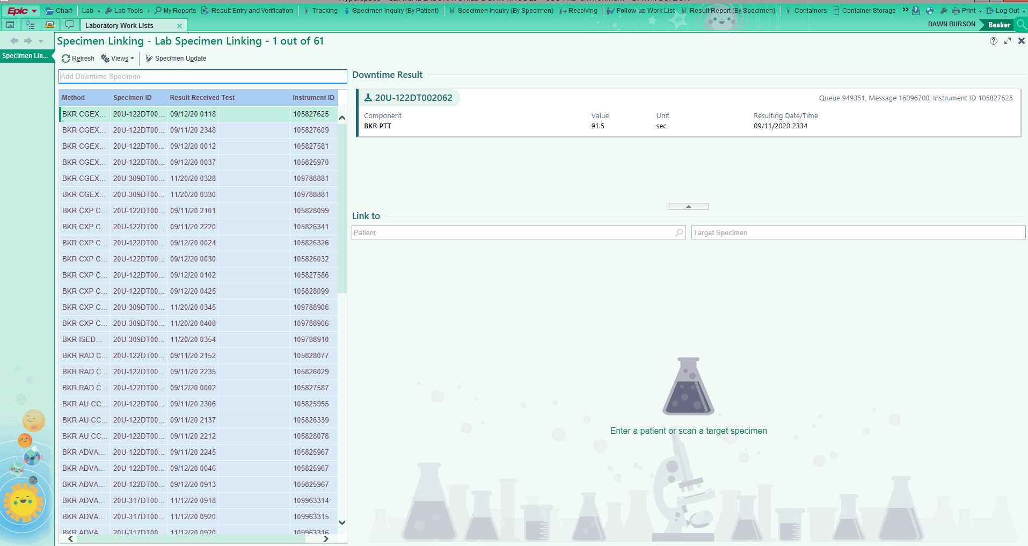

* + 1. Scan or type the uptime label into the Specimen field in the right pane.

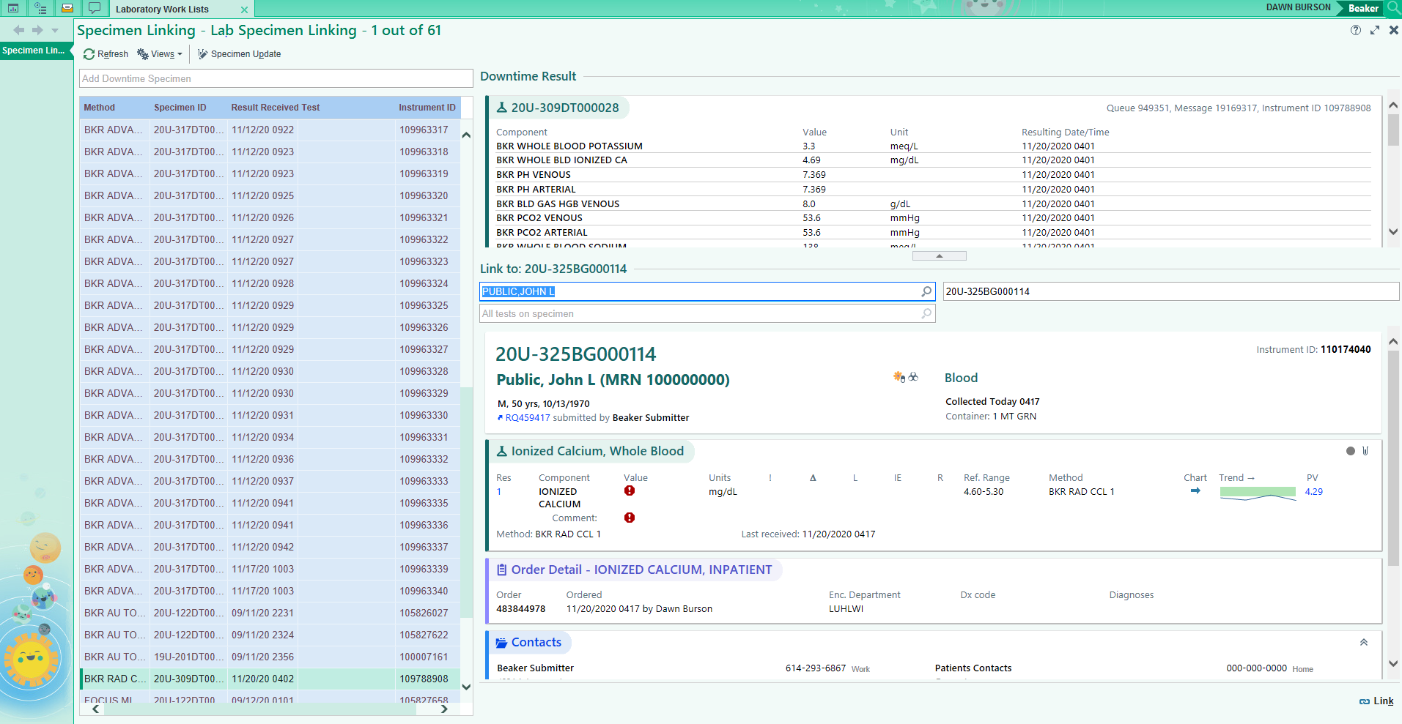

* + 1. Using the requisition, confirm the uptime label and downtime label match for patient information (legal name and MRN) and test(s) ordered.
    2. Click the search icon in the Test field and ensure the ordered test(s), specimen ID, and MPI match the requisition information.

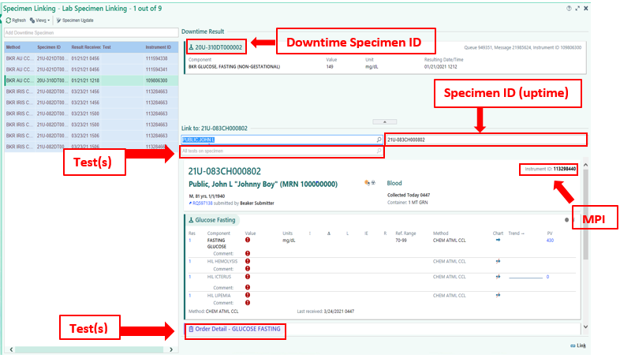

* + 1. Click Link, Located at the bottom of the screen, if uptime label is scanned.

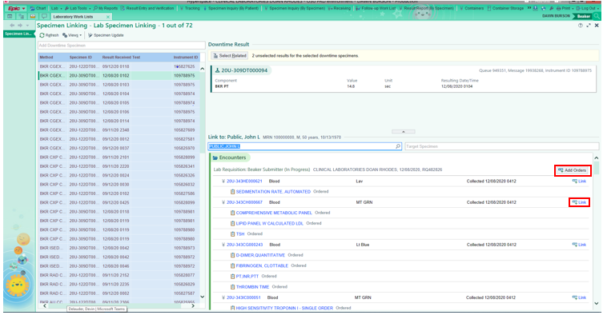

* + 1. If the patient MRN is known and you do not have the uptime MPI you can look up the patient by just the MRN. Find the correct order to use and cick link. Located again on the left side, directly across from the order. This will only be performed if the patient was already collected prior to the downtime.
    2. You can also click on Add Orders tab on the right to create orders for that patient. If you click on Add Orders you will need to have a ICD.10 diagnosis code to complete the linking.
       1. NOTE: Once you put in the test code and the diagnosis, you will need to click on recalculate specimen details to enter in the collect and receive time.
    3. Once all information has been input into deisred/required fields, you can select Create, Receive and Link in the lower right had corner of the screen.

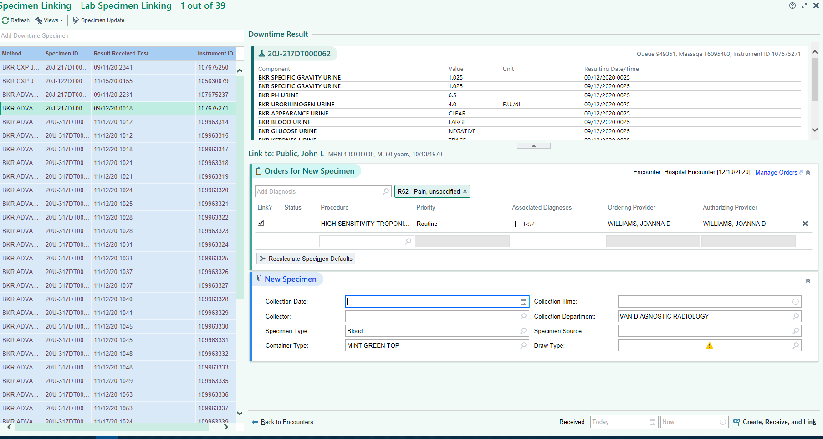

* + 1. Once the uptime and downtime information is linked the specimen will auto file if all information is within normal ranges, or will move to the Outstanding List, if any abnormalities exist/more information is needed.
    2. NOTE: If you are performing final verification on this sample you will not need to have a second technologist review the results. This final verify is considered your second check and will not require a review by a second technologist.
    3. If the specimen auto filed, linking technologist must review and verify the results using the downtime requisition to confirm all information matches (patient legal name and MRN, uptime label, downtime label, and test(s) ordered). Refer to Admin-147 Beaker Activities Overview.
    4. If any results are manually entered for any reason, a second technologist must review and verify the results using the downtime requisition to confirm all information matches (patient legal name and MRN, uptime label, downtime label, and test(s) ordered). Refer to Admin-147 Beaker Activities Overview.
    5. Return the requisition to the processing area. All manual/downtime requisitions will be scanned into IHIS. Refer to Admin-147 Beaker Activities Overview (Requisition Entry section).

1. **RELATED DOCUMENTS**
   1. **Refer to QPulse System or Document Detail Report for related Laboratory Policies, Procedures, and Master Forms**