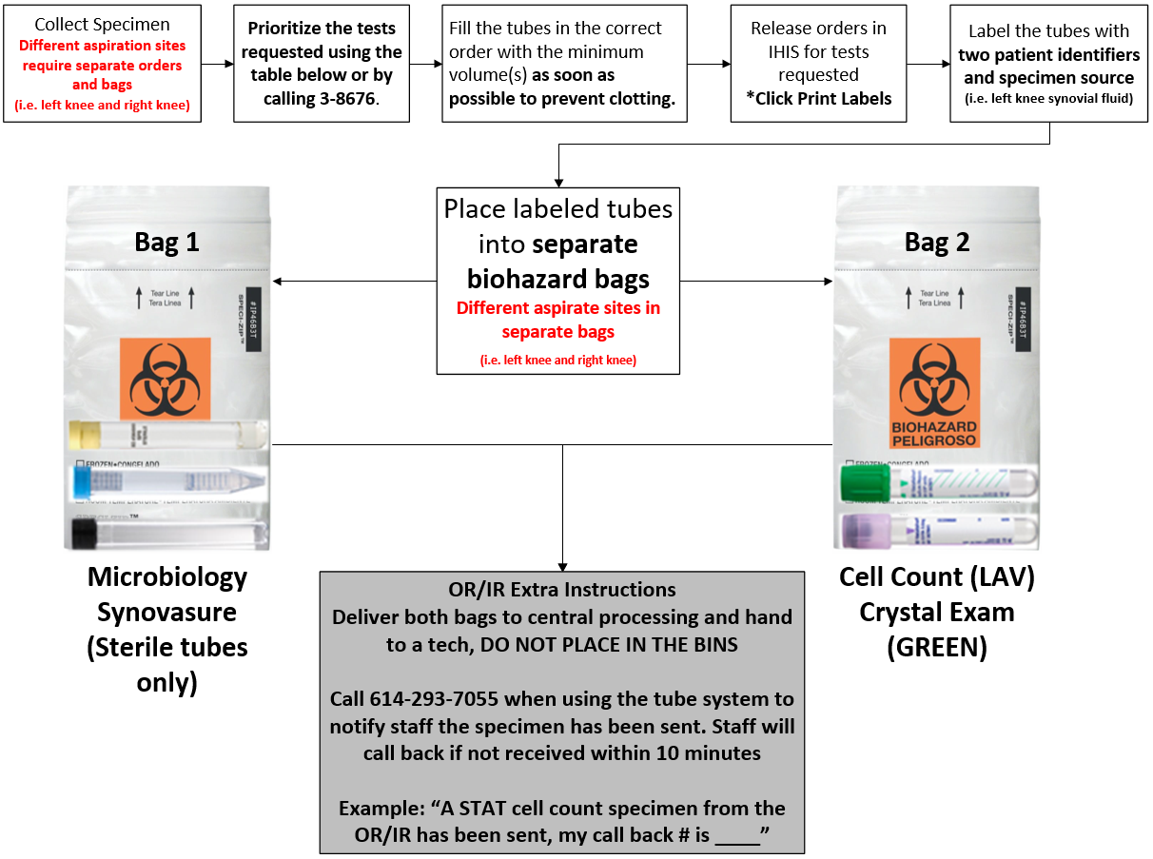
Call back #______________
Standard Order Priority List
Notify the lab if the priority needs modified
- Aerobic Culture  - Cell Count with Differential  - Anaerobic Culture  - Synovasure |  |  | - Leukocyte Esterase  - Fungus Culture  - Acid Fast Bacilli Culture  - Crystal Exam
Test | Tube and Volume | Comments
Microbiology Culture | SPS, Any Sterile Tube  Minimum 1.0 mL | Body fluid submitted with Eswabs, EDTA (LAV top), heparin (green top) or other anticoagulants other than SPS are unacceptable for culture.
Synovasure | Any Sterile Tube  Minimum 1.0 mL
Cell count | LAV Top – Preferred  Or Green Top  Minimum 0.5 mL* | Add fluid immediately after collect and gently mix by inversion 8 times to prevent clotting  *Use LAV for cell count and crystals if <1mL available
Crystal Exam | Green Top - Preferred  Or LAV Top  Minimum 0.5 mL* | Add fluid immediately after collect and gently mix by inversion 8 times to prevent clotting  *Use LAV for cell count and crystals if <1mL available

