

Welcome to the

**Clinical Laboratory Guide to Services**

Available on MyTools

Laboratory Contacts

Customer Service

614-293-8375

(Inpatients/Outpatients)

Pathology Results

614-293-5905

James Oncology Lab

614-293-8616

Outreach Customer Service

614-293-9281

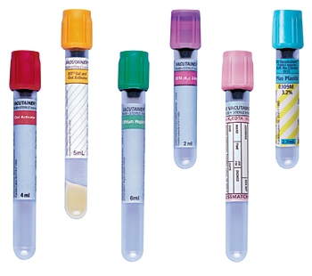

1-800-227-5062

OSUWMC Staff should use MyTools to access additional content.

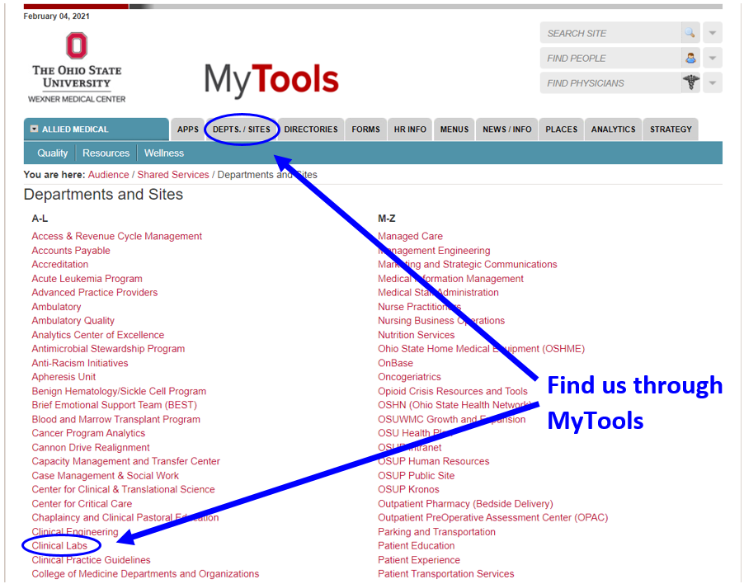

Click on “DEPTS. / SITES”

🡪 Clinical Labs

Or

🡪 Laboratory Guide to Services

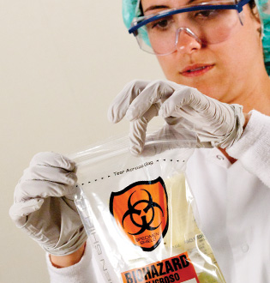

Outside Clients can

visit us here:

clinicallabs.osumc.edu

 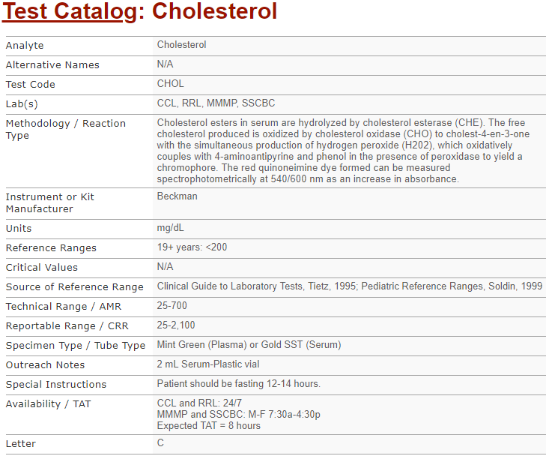

**Reference Ranges:** Describes reference intervals. Includes intervals based on age and sex as appropriate.

**Critical Values:** Values at which the lab will contact the clinical team so that urgent treatment may be initiated if applicable.

**Specimen Requirements:** Defines acceptable specimen type(s) and any other specimen requirements.

**Availability / TAT:** Indicates location of the laboratory that performs the test and outlines the days/times the test is performed. Also defines expected turnaround time from specimen receipt until release of test result.

**Point of Care Testing**

***Web page has all related documents grouped by instrument***

* Package Inserts
* Policies and Procedures
* Competency Forms
* Quick Guides
* Temperature and Maintenance Logs
* Operators Manual
* Safety Data Sheets (SDS)

**Test Catalog:**

***Includes testing information for send out testing to referral laboratories***

**Included testing information:**

* Detailed Methodology
* Reference Ranges
* Critical Values
* Specimen Types
* Collection Information
* Expected Turnaround Time

***Clinical Laboratory Guide to Services***

*Your portal to laboratory information*

clinicallabs.osumc.edu

**Laboratory Policies and Procedures**

* Point of Care Testing Documents
* IHIS Policies and Tip Sheets
* General Policies and Procedures
* Downtime Policies and Procedures

**Forms and Requisitions**

* Requisitions are purchased through the contracted vendor RR Donnelley

**Transfusion Services**

* Blood Product Guidelines
* Guides for Specimen Labeling
* Blood Utilization

**Compliance / Accreditation**

* Proficiency Testing Information
* Laboratory Accreditation Information
* CLIA and CAP Certifications

