**CONCLUSION**

Providing lab results requires everyone’s cooperation. The process of drawing the blood is the most crucial step to obtaining accurate results. **Thank you** for all of your hard work and dedication to providing the best care possible for our patients.

For more comprehensive information, refer to the [Standards for Acceptable Clinical and Anatomic Pathology Specimen Collection](https://clinicallabs.osumc.edu/Documents/Specimen%20Collection%20and%20Acceptable%20Specimen%20Types.pdf) on *OneSource*

**THANK YOU**

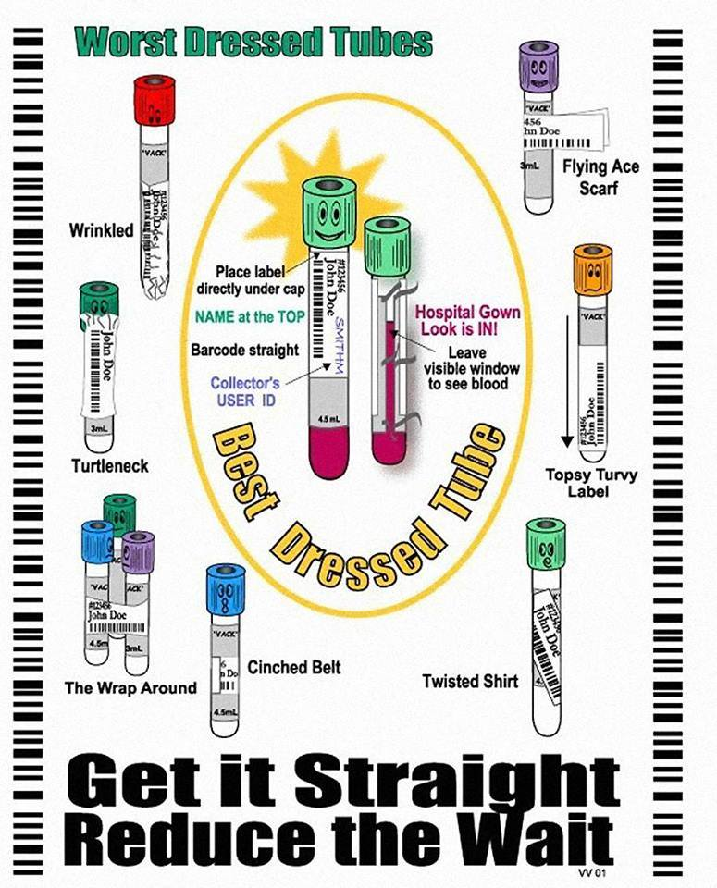

|  |  |
| --- | --- |
| **Lid Color** | **Collection Tube / Additive** |
|  | **BD Bactec Blood Culture Collection Tubes**  **8-10 mL of blood for full draw**  **1-3 mL of blood in pediatric draw vials**  **OR** |
|  | **BD Vacutainer SPS Culture Tube** |
| **If not drawing blood culture, START here:** | |
| **If drawing with a butterfly or from a line, an appropriate amount of waste blood must be drawn for discard to eliminate contamination and erroneous results. Typically one waste tube or 5ml.** | |
|  | **Citrate Tube: must be filled to fill line** |
| **If not drawing blood cultures or coagulation testing, START here:** | |
|  | **BD Vacutainer SST Gel Separator Tube** |
|  | **Serum Tube no gel** |
|  | **Heparin Tube (lithium or sodium depending on test)** |
|  | **EDTA Tubes** |
|  | **Fluoride (glucose) Tube** |

**ID badge order of draw tip sheets available through RR Donnely MC202531**





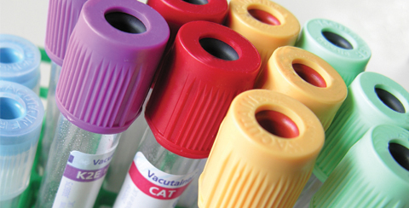

**Effects of Improper Specimen Collection**

**Department of Clinical Laboratories**

**The Ohio State University Wexner Medical Center**

Revision 3

Effective 03/2021

**HEMOLYZED SPECIMENS**

Hemolysis is caused when red blood cells (RBCs) are destroyed and hemoglobin is released into the plasma or serum. Hemolysis can be seen after the blood sample is spun down in a centrifuge. The plasma or serum will be pink (slight hemolysis) to red (gross hemolysis). Use a **21 gauge needle** whenever possible based on the patient’s vein to be accessed

**Patient Conditions that May Cause Hemolysis**

* Hemolytic anemia
* Liver disease
* Transfusion reactions

**Procedural Causes of Hemolysis**

* Collecting blood when starting an IV
* Using a needle with a bore too small for the vein
* Using too large of a tube when using a small-diameter butterfly needle
* Drawing blood from a vein that has a hematoma
* Continuing sluggish draws caused by collapsed veins or improper needle placement
* Excessive squeezing of the site when obtaining a skin puncture specimen
* Mixing the tubes too vigorously or rough handling during transport
* Frothing of the blood caused by improper fit of the needle on a syringe
* Excessive force on the syringe plunger
  + keep < 1 mL dead space
* Forcing the blood from a syringe into an evacuated tube

**STERILE TECHNIQUE**

* Clean with 70% alcohol or >0.5% Chlorahexadine Gluconate sponge prep (Chloraprep) with back and forth motion
* Use needles **one time only**

**UNDERFILLED/OVERFILLED TUBES**

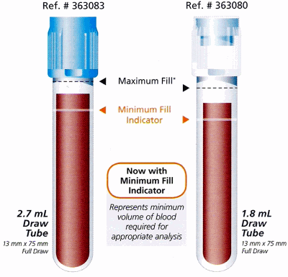Tubes that are not filled to their stated capacity can lead to **erroneous lab results** for some tests. Drawing enough blood is particularly important for coagulation testing (light blue sodium citrate tubes).

The sodium citrate tube must be filled to the line. There is a crucial 9:1 ratio of blood to anticoagulant. If the ratio is disturbed by **either** **too little or too much blood** (the tube is filled up to the cap) the lab results will be inaccurate.

It is also very important to draw a **discard tube before collecting a sodium citrate tube** because of tissue thromboplastin (a clotting factor that is activated when the skin is pierced). If using a butterfly, a discard tube ensures the tube will fill properly by getting rid of the air in the tubing.

**IMPROPERLY COLLECTED OR PATIENT ID ERRORS**

Correct identification of patient specimens **using 2 patient identifiers** is essential for reporting accurate laboratory results. Documenting specimen collection via scanning and proper label placement is critical to safe, accurate, and timely lab completion. Follow the steps outlined in the [IHIS specimen collection tip sheets](https://onesource.osumc.edu/departments/IHIS/Pages/Tip%20Sheets.aspx?RootFolder=%2Fdepartments%2FIHIS%2FTip%20Sheets%2FLabs%20and%20Results&FolderCTID=0x012000F48BFC14987803418B02C012E137C8D8&View=%7B2C37F870%2DF76C%2D4438%2DAC38%2D202EE771B0EB%7D) with the following key takeaways:

* Always **Scan Before you Move** to complete the collection documentation, including clicking **[Accept]**
* Always document the source for specimens other than blood **including specimen type and collection site**

A variety of blood collection tubes and urine preservatives are necessary to maintain specimen stability until testing can be performed in the laboratory. Refer to the Lab Testing Menu on *OneSource*or the lab test label for acceptable tube types.

[**https://clinicallabs.osumc.edu/Pages/TestCatalog.aspx**](https://clinicallabs.osumc.edu/Pages/TestCatalog.aspx)



**CLOTTED SPECIMENS**

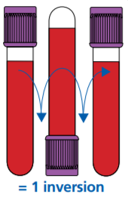Lack of or inadequate mixing of tubes is the major cause of clot formation. To help stop the specimen from clotting, mix the tube by **gently** inverting it a minimum of 3 times **immediately** after filling it with blood. Then continue to **gently** invert the tubes a total of **8 times** to completely mix. Line draws into a syringe must be transferred without delay and gently mixed to avoid clotting.

**IV CONTAMINATION**

Obtaining specimens from indwelling lines or vascular access devices can be a potential source of test error due to hemolysis or contamination with fluid and/or medication due to incomplete flushing of the collection site. **Whenever possible, blood must be collected from the opposite arm of VADs and infusions.** If blood needs to be collected on an arm in which an infusion is taking place, please refer and adhere to the [*Intravascular Access Devices, Peripheral and Central (Nursing)*](https://policytech.osumc.edu/docview/?docid=61021&anonymous=true) policy.

**HOW DOES THIS AFFECT TEST RESULTS?**

**Hemolysis -** Falsely increased potassium (K), Magnesium (Mg), Phosphate, D-Dimer is affected unpredictably

**Clotted** - Falsely decreased platelets (plt) and hemoglobin (Hgb), and the PT and PTT can be either falsely increased or decreased depending on the size and composition of the clot

**IV Contamination** – Affects many analytes due to a dilution effect and contamination of the fluids/medications. Examples include falsely low Hgb, plt, and WBC count, falsely increased sodium (Na), Chloride (Cl), and PT/PTT

**EDTA Contamination in a Chemistry tube** = Falsely increased K and falsely decreased Calcium (Ca)

**Delayed turnaround time -** Recollecting the sample adds time

**Prolonged tourniquet time** - Possible hematoma formation and erroneously high values for all protein based analytes, Hgb, and other cellular elements. **Do not exceed 1 minute.**

**Patient ID Errors -** Potential for serious injury to the patient if clinical decisions or blood products given based on mislabeled specimens