Placing Orders

- Login to eRAMP website

- The first step is to click the ‘New Order’ button from the main page of eRAMP

*if you have funds left in your buffer, use ‘Existing Orders’ to skip to step #5
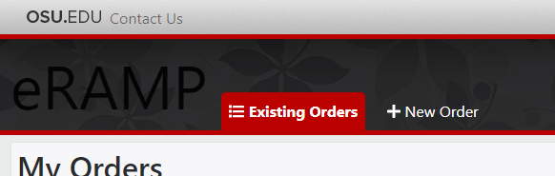

Select the appropriate Shared Resource and click ‘Save and Next’:
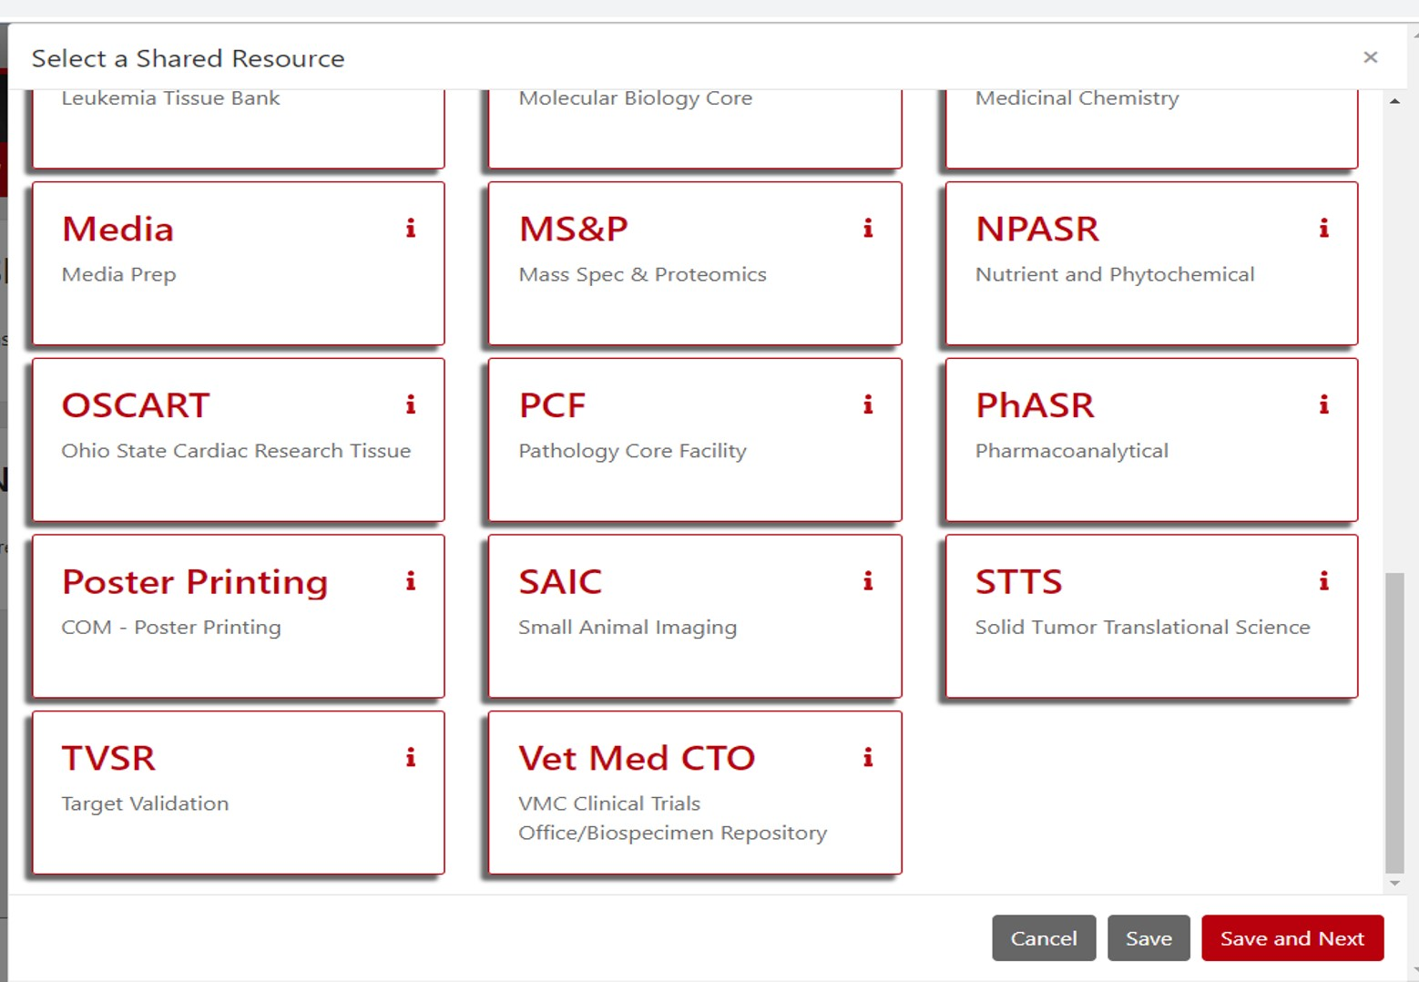

- Choose a PI and click ‘Save and Next’:
(Name column headers can be filtered)

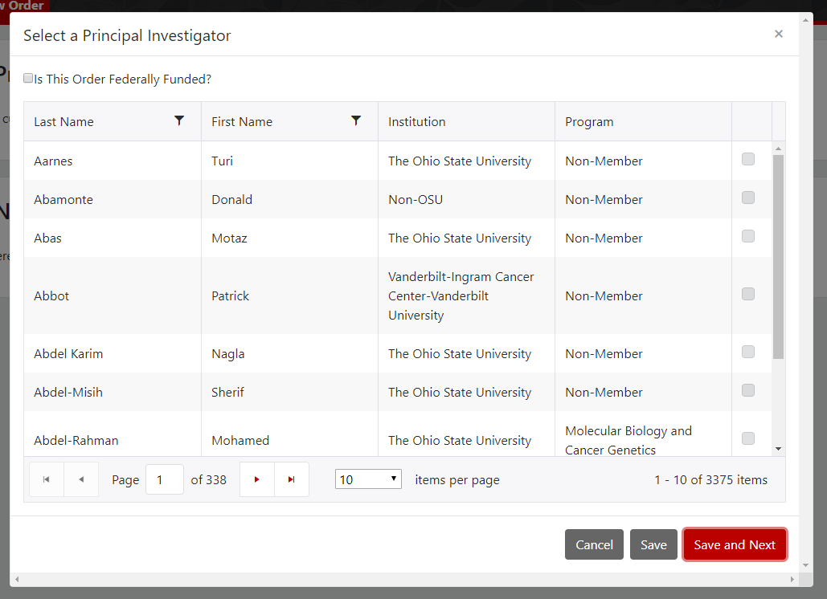

- Choose a collaborator (optional) and click ‘Save and Next’
(Name column headers can be filtered)

Add all collaborators (users) scheduling product\service\systems.

- Schedule time on a resource by selecting the ‘Schedule’ option:
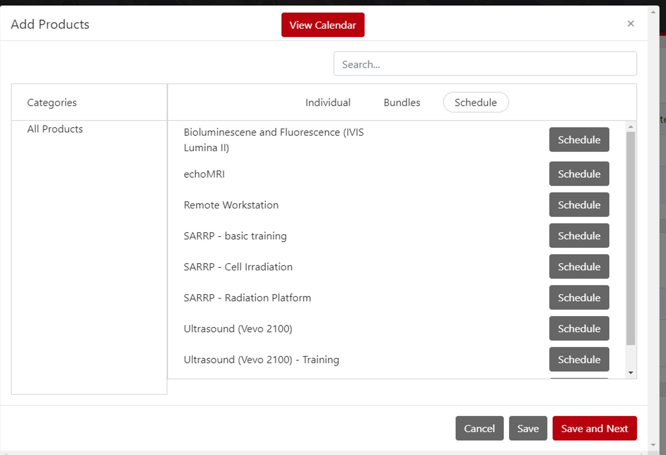

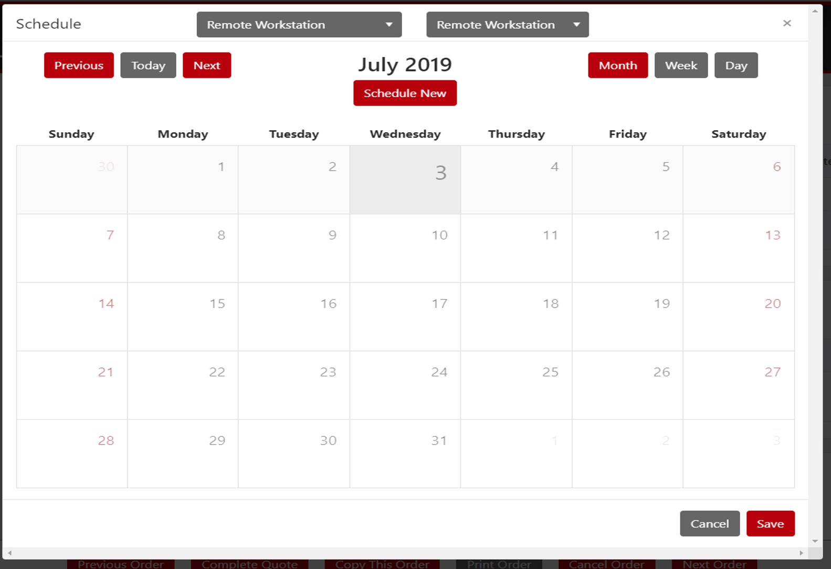Click the “Schedule” button next to the appropriate machine to access the calendar view. Select the appropriate day and click “Schedule Now” near the top of the window:

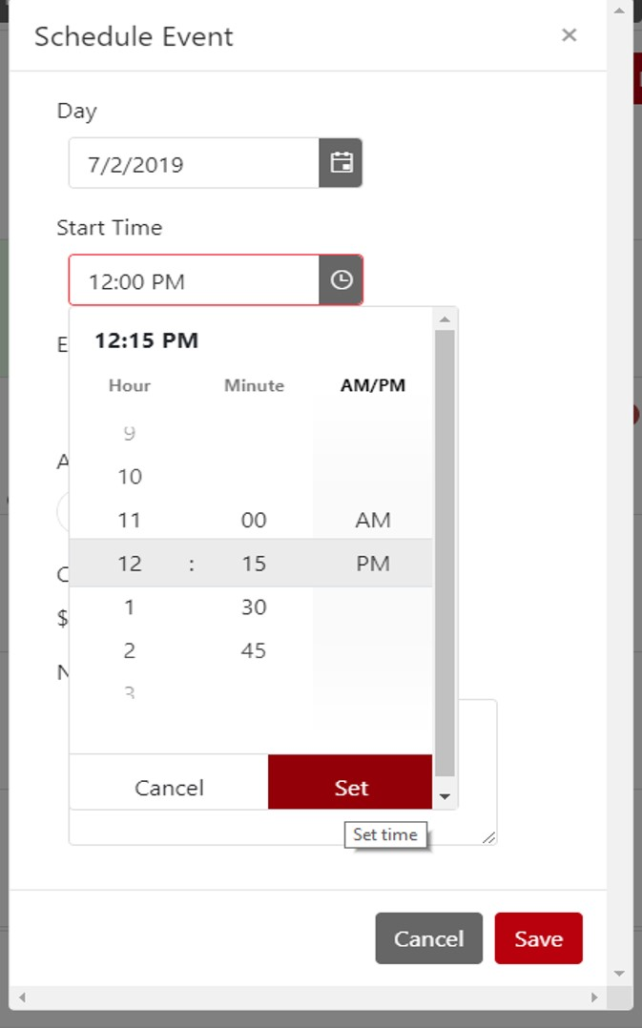
Make sure to select a start time (confirm by clicking Set), end time (click Set), indicate whether assistance is needed and add any relevant notes. Once you are done, select Save and close out of the calendar popup box.

- Next, enter the relevant Billing information. To add billing information, select ‘Add Account’ and enter the correct chartfield combination OR enter a PO number if you are an external user.
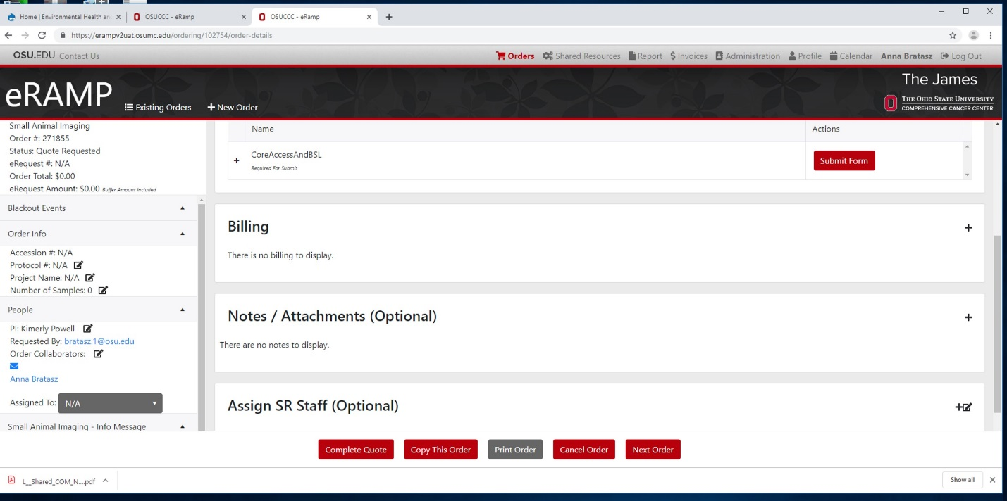

- Next, under the Forms section select the ‘Submit Form’ button for the Core Access form, complete the form and follow the instructions.

- Finally, depending on the order, either request the quote or “Submit Order” using the bottom navigation bar.
If you would like to keep this order open for additional services in the future (e.g. second imaging time point = next calendar event) please add an additional “Buffer” in $ amount.

Notes:
If you are not scheduling any event, skip 5) and add Buffer in an amount you would like e-request to be approved.
Your order needs to be submitted in order to reserve requested time for any product\system.
You do need to attach Core Access Form to each order. This needs to reflect information about current studies. If there would not be any changes to any information on the form, the form is valid till June 30th, 2020.
- TO ADD event to existing order login to eRAMP, open your order and click “+” sign, in the right upper corner, next to “Products” line

