REMOTE DESKTOP ACCESS TO IVIS AND VEVO WORKSTATIONS

The Remote Workstation is accessible through Windows Remote Desktop Connection. You can access that application by typing “remote” into the Start Menu. Open that application, input DHLRI-1294 as the computer name, and use your OSUMC credentials. You will have to specify your login is coming from the OSUMC domain by appending OSUMC\to the beginning of you username when submitting your credentials.

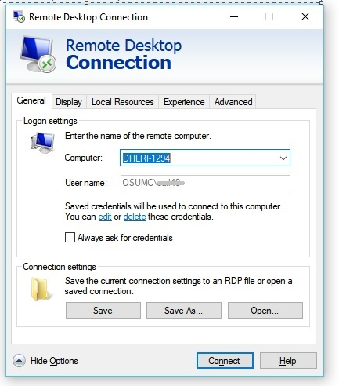

This will work anywhere on the OSUMC network, and everyone should have 24hr access to the scheduler for the remotely accessible software. Contact DHLRI.SAIC@osumc.edu if this is not the case.
The Workstation located in 0020 BRT and the Remote Workstation are both schedulable through eRamp at a $0 price point.

