PREPARE for Autistic Adults
Facilitator Guide - Standardized Patient Encounters

Table of Contents
Preparing for Standardized Patient Encounters 2
Resources 2
Overview 2
Five Easy Steps 2
Rash Standardized Patient Encounter 3
PREPARE for Autistic Adults Modules Covered 3
Trainee Objectives 3
Before the Encounter 3
Begin the Encounter with the Following Prompt 4
After the Encounter, Provide Feedback 4
Migraine Standardized Patient Encounter 5
PREPARE for Autistic Adults Modules Covered 5
Trainee Objectives 5
Begin the Encounter with the Following Prompt 5
After the Encounter, Provide Feedback 5

Preparing for Standardized Patient Encounters

Resources
- Facilitator guide – PREPARE for Autistic Adults curriculum
- Facilitator guide – Standardized patient encounters
- Patient training – Standardized patient encounters
- Patient handout – Standardized patient encounters
- Learner handout – Standardized patient encounters

Overview
During these 10-15 minute standardized patient encounters, learners are encouraged to implement knowledge and strategies from the weekly modules. After the encounter, learners are provided with 5-10 minutes of feedback, both from a facilitator as well as from the standardized patient.
The patients in these encounters should be portrayed by autistic adults (not neurotypical people pretending to be autistic), who are paid for their time.

Five Easy Steps
Follow these steps to prepare for standardized patient encounters:
- Familiarize yourself with the standardized patient encounter. Review the goals of the encounter, and the information provided to standardized patients (see Patient handout – Standardized patient encounters).
- Decide on the logistics. Based on the needs and resources at your institution, decide if the standardized patient encounter will be conducted virtually or in-person. Encounters may be conducted in person or via videoconferencing as they do not require any “hands-on” examination. Consider the number of learners you have and number of standardized patients you will need. Identify resources to pay standardized patients.
- Identify autistic adults to portray the standardized patients. For ideas on where to find autistic standardized patients, see “Recruiting Autistic Co-Facilitators or Panel Members” section in the “Facilitator guide – PREPARE for Autistic Adults curriculum” document.
- Prepare the standardized patients. It is important that the autistic adults portraying the standardized patients feel adequately prepared for these encounters. Once you have identified who will be portraying the standardized patients, send them the document “Patient handout – Standardized patient encounters” and the slides “Patient training – Standardized patient encounters” for their review so they can know what to expect. Next, spend 20-30 minutes meeting with the standardized patients. You may do this a week or so in advance of the encounters (preferred) or immediately before the encounters. Give them a chance to ask you questions about the case portrayals. Go through the slides “Patient training – Standardized patient encounters.” Allow them to ask questions.
- Use the facilitator guide to conduct the standardized patient encounters. Read the prompt to the learners before the encounter. Observe the encounter. Provide feedback after the encounter. Allow standardized patients to also provide feedback after the encounter.

Rash Standardized Patient Encounter

PREPARE for Autistic Adults Modules Covered
- Patient-centered care
- Contextual and conceptual frameworks
- Clinical assessment
As such, this standardized patient encounter is designed to be delivered after these modules have been completed.

Trainee Objectives
- Use principles of patient-centered care (e.g., use plain language, ask about sensory needs, assume competence)
- Adapt to the patient’s communication needs
- Recognize that autism is one demographic characteristic and does not negate the need for regular medical care for physical and mental health conditions as they arise

Before the Encounter
For in-person implementation, print out pictures¹⁻³ of the rashes below and ask the standardized patient to provide the one that best matches their skin tone to the resident at the start of the encounter.
For virtual implantation, using the chat feature of the videoconferencing software, send the resident the photo¹⁻³ that best matches the actor’s skin tone.
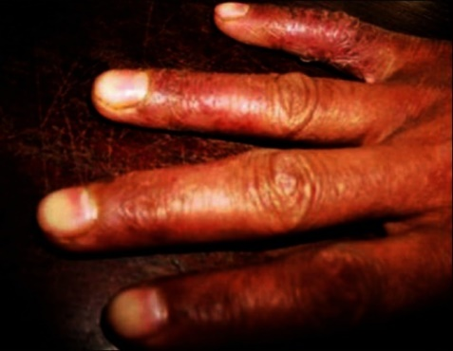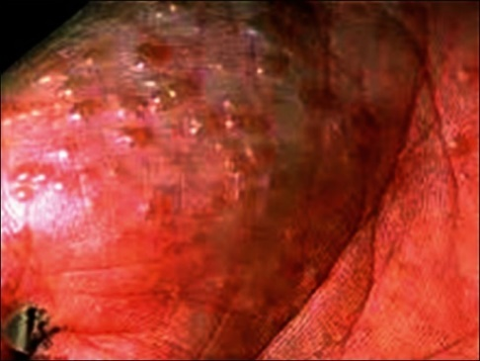

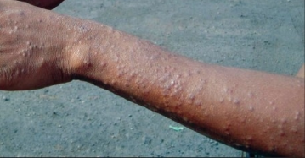
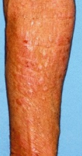

Begin the Encounter with the Following Prompt
“The standardized patient in this encounter is acting out a scenario but they are actually autistic. The patient’s name is ____. The patient is presenting with a rash on their arms and hands and has sensory and communication needs. The primary goal of this encounter is to practice principles of patient-centered care while identifying a care plan for the patient’s primary concern today. You will have 10-15 minutes to talk to the patient, followed by 5-10 minutes of feedback.”

After the Encounter, Provide Feedback
- Start by emphasizing what the trainee did well
- Feedback should primarily focus on the interpersonal skills with the patient rather than their medical decision-making. However, by the end of the encounter ideally they will have landed on a treatment plan that the patient is comfortable with
- Try to identify at least one constructive point per trainee
- Avoid comparing trainees to each other
- Consider:
  - Did they pause long enough for the patient to respond, or did they try to fill the silence by repeating or restating their questions?
  - Did they ask the patient how they receive information most effectively (e.g., verbal vs. written communication)?
  - Did they brainstorm with the patient how they can still perform this activity of daily living (dishwashing) while accommodating their sensory needs and acute health condition?
  - Did the trainee explain things in plain language (e.g., not too much jargon)?

References
- Images by Charan UP, Peter CV, Pulimood SA - Indian dermatology online journal (2013) retrieved from http://www.ncbi.nlm.nih.gov/pubmed/23741665 on 12/17/25. Creative Commons License associated: CC BY-NC-SA 3.0.
- Image by Sarma N - Indian journal of dermatology (2009) retrieved from http://www.ncbi.nlm.nih.gov/pubmed/20101309 on 12/17/25. Creative Commons License associated: CC BY 2.0.
- Image by Tanei R, Hasegawa Y, Sawabe M - Journal of the European Academy of Dermatology and Venereology (2012) retrieved from http://www.ncbi.nlm.nih.gov/pubmed/22702954 on 12/17/25. Creative Commons License associated: CC BY 2.5.

Migraine Standardized Patient Encounter
Before this encounter, ensure the actor portraying the standardized patient and the actor portraying the supporter have been introduced. Ask them how they’d like to describe their relationship to the residents during the mock clinical encounter. Options we have seen include (but are not limited to) describing the supporter as the autistic adult’s sibling, neighbor, or trusted friend who provides informal decision supports.

PREPARE for Autistic Adults Modules Covered
- Legal obligations
- Team-based practice
- Care across the lifespan and transitions
As such, this standardized patient encounter is designed to be delivered after these modules have been completed.

Trainee Objectives
- Understand the role a supporter may play in caring for autistic adults, and how this may vary based on the type of supported decision-making arrangement in place
- Use strategies for shared decision-making
- Recognize the need to manage health conditions, including those that are more common among autistic people than the general population

Begin the Encounter with the Following Prompt
“The standardized patient in this encounter is acting out a scenario but they are actually autistic. The patient’s name is ____. The patient is presenting with recurrent migraines and is coming to see you with a supporter. The primary goal of this encounter is to apply shared decision-making strategies with the patient and supporter, while identifying a care plan for the patient’s primary concern today. You will have 10-15 minutes to talk to the patient, followed by 5-10 minutes of feedback.”

After the Encounter, Provide Feedback
- Start by emphasizing what the trainee did well
- Feedback should primarily focus on the interpersonal skills with the patient and supporter rather than their medical decision-making. However, by the end of the encounter they will have ideally settled on a treatment plan that the patient is comfortable with
- Avoid comparing trainees to each other
- Try to identify at least one constructive point per trainee
- Consider
  - Did the trainee primarily address their questions to the patient (preferred) or to the supporter?
  - Was shared decision-making used to decide how to manage the increased frequency of the patient’s migraines?
  - Did the trainee demonstrate active listening (e.g., summarizing what they understood the patient and/or supporter to have said and checking for their understanding)?
  - If medications were discussed, were side effects explained so the patient can make an informed decision?
  - Did the trainee explain things in plain language (e.g., not too much jargon)?

